Title of the Abstract: Homology Modelling of Lycopene Cleavage Oxygenase: The Key Enzyme of Bixin Production
Author (s) Name & Affiliation: First Author’s Name *, Second Author’s Name
*University of Oxford, UK
Cambridge University, UK
(* Represents Presenting Author)
Email: Presenting Author’s email

Abstract:
Bixin is a natural dye and a high commercial important compound, produced from Bixin synthetic pathway in case of Bixa orellana plant. The particular enzyme Lycopene cleavage Oxygenase catalyzes the first step of reaction pathways from Trans-lycopene to Bixin synthesis. The 3D structure of the enzyme was predicted by MODELLER program and the missing side chains were verified by SCRWL4 tool. Model validation was done by using the output of PROCHECK and DOPE score. (Up to 300 words).
Keywords: Bixin, Homology Modelling, Docking, RC Plot

Figures/ Images/ Graphs/ Table (both Color and BW) if any

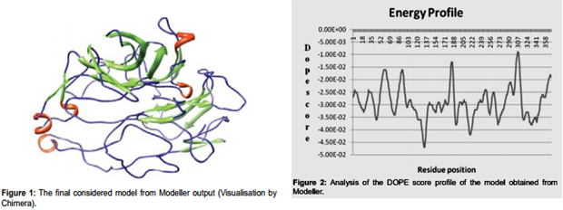

Biography:
John has completed his PhD from Oxford University. He is the Head of the department of Biology and dean of a premier research institute. He has published more than 35 papers in reputed journals and has been serving as an editorial board member of repute journals. (Up to 100 words)
Research Interest: Bioinformatics, Drug Designing, Chemo Informatics

Author Information (Presenting Author)
Name
University/Organization
Country
Mobile Number
Email:
Category of Presentation

Author’s Recent Photograph

Author’s University/Organization’s Logo

Note: Abstracts should be submitted as per the template format including Presenting Author’s information as given below. Presenting Author’s information is required for Scientific program, Certificate and ID Cards purpose.

